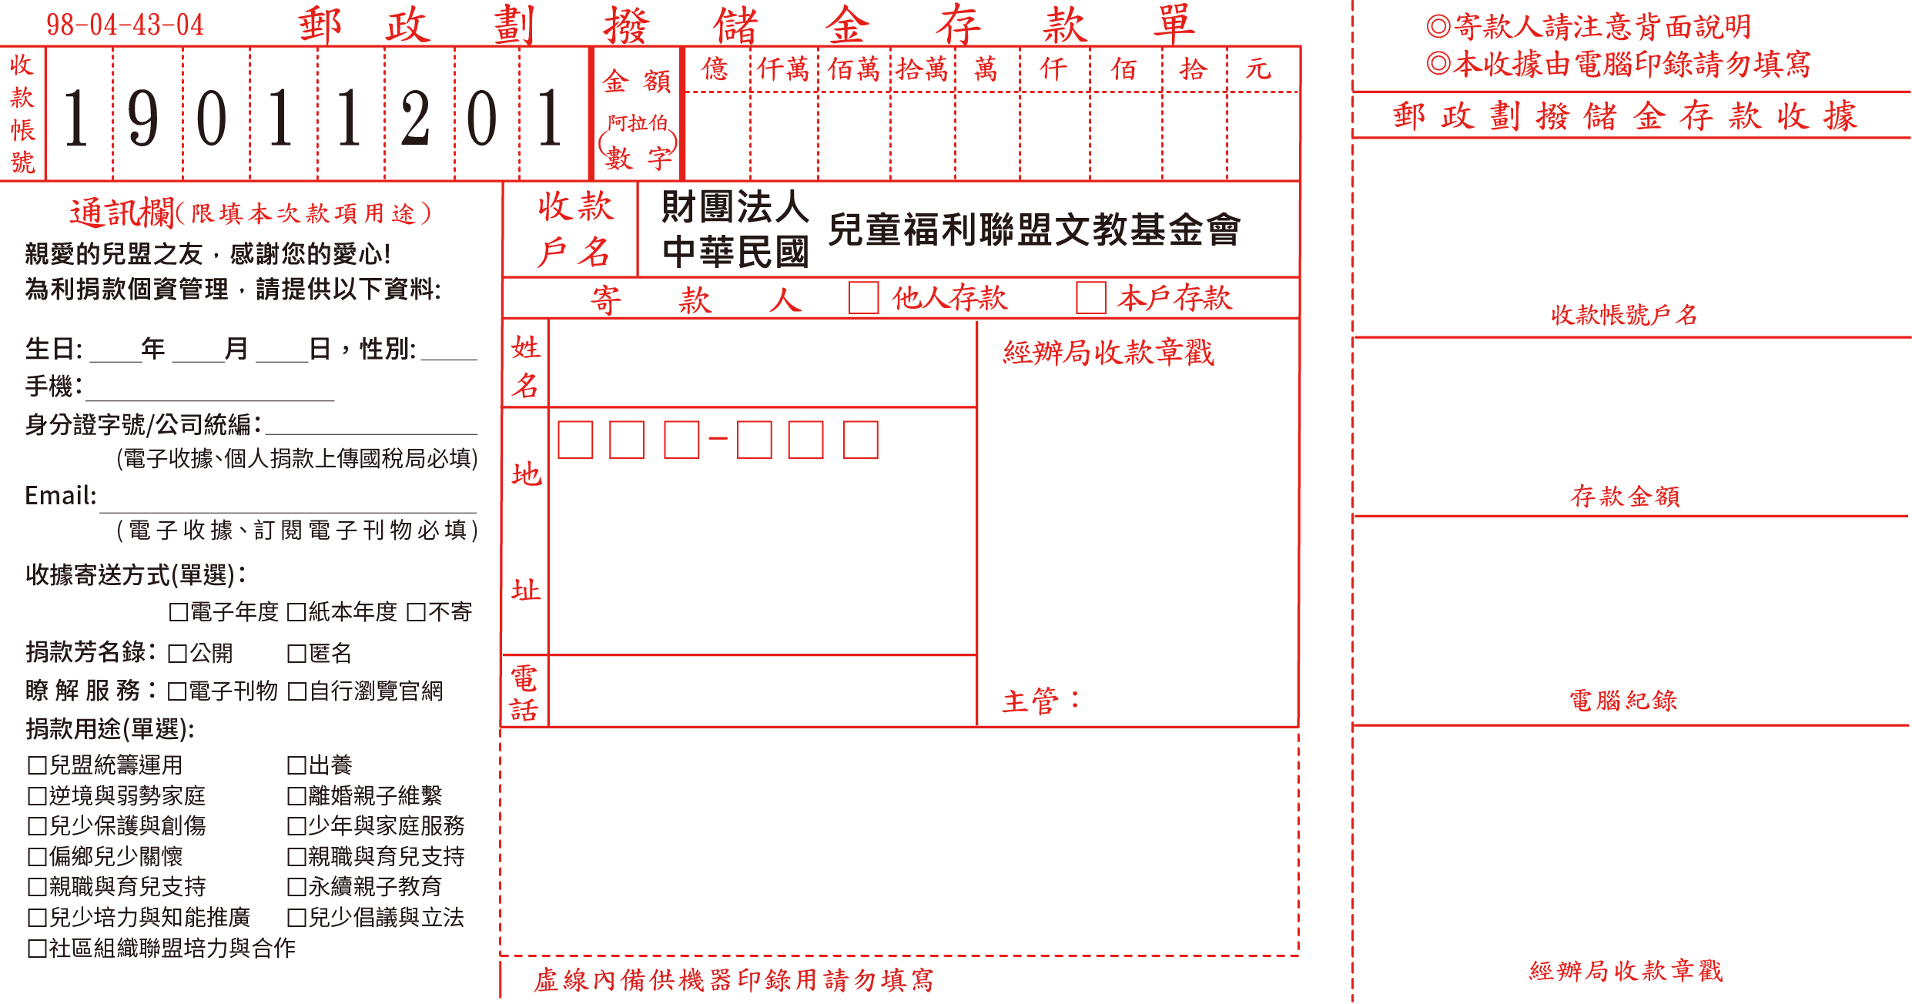

3
--------------------------------------------------------------------------------------------------------------------------------------------------------

----------------------------------------------------------------------------------------------------------------------------------------------------------

