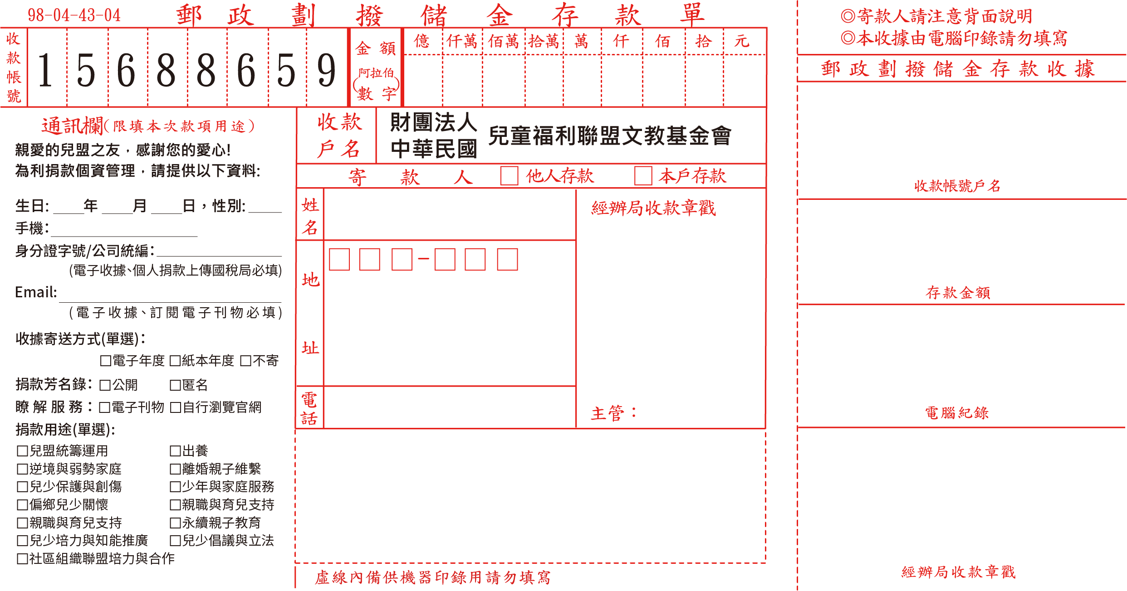

3
----------------------------------------------------------------------------------------------------------------------------------------------------------

----------------------------------------------------------------------------------------------------------------------------------------------------------

